**Aim:**

To design and implement a **cloud-based Property Buying & Rental application** using **Zoho Creator** that allows users to list, search, and book properties (buy/rent) in **Chennai city**, demonstrating the **Software as a Service (SaaS)** model.

**Procedure:**

• **Login to Zoho Creator**

* Open Zoho Creator and sign in with your Zoho account.

• **Create a New Application**

* Click **Create Application → From Scratch**.
* Name it: *Property Buying & Rental (Chennai)*.

• **Design the Property Form**  
Create a single form named **Property Details** with the following fields:

* Property ID (Auto-generated)
* Owner Name (Text)
* Contact Number (Phone)
* Property Type (Dropdown: Apartment, Villa, Plot, Commercial)
* Purpose (Dropdown: Buy, Rent)
* Location (Dropdown: T. Nagar, Anna Nagar, Velachery, Adyar, etc.)
* Price (Currency)
* Status (Dropdown: Available, Sold, Rented)

• **Design the Buyer/Tenant Request Form**  
Create another form named **Buyer Request** with these fields:

* Request ID (Auto-generated)
* Name (Text)
* Contact Number (Phone)
* Email ID (Email)
* Requirement (Dropdown: Buy, Rent)
* Preferred Location (Dropdown: T. Nagar, Anna Nagar, Velachery, Adyar, etc.)
* Budget (Currency)

• **Create Reports (Views)**

* Add a report table **Available Properties** to display all properties where Status = Available.
* Add a report table **Buyer Requests** to display all buyer/tenant requests.
* Enable search and filters by Location, Purpose, and Price.

• **Add Workflow (Optional)**

* Use a **Deluge script** to automatically check if properties match a buyer’s budget and preferred location.
* Optionally send an **email confirmation** to the buyer/tenant after submitting a request.

**Property:**

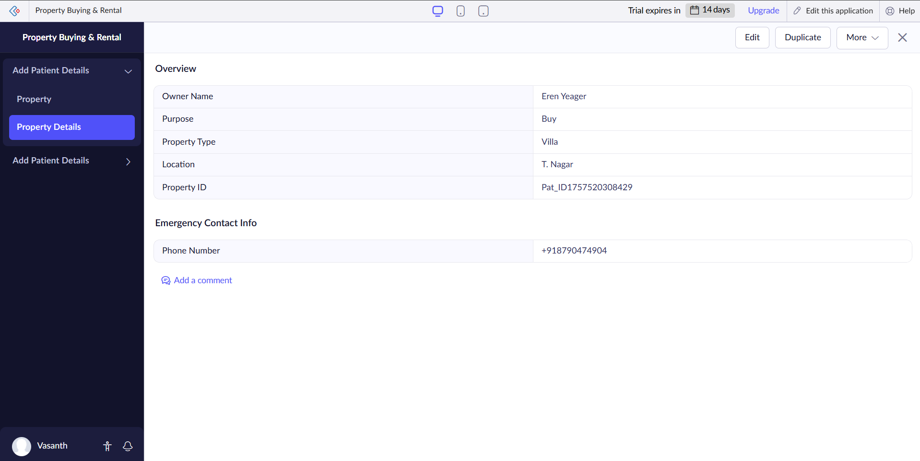

**Buyer:**

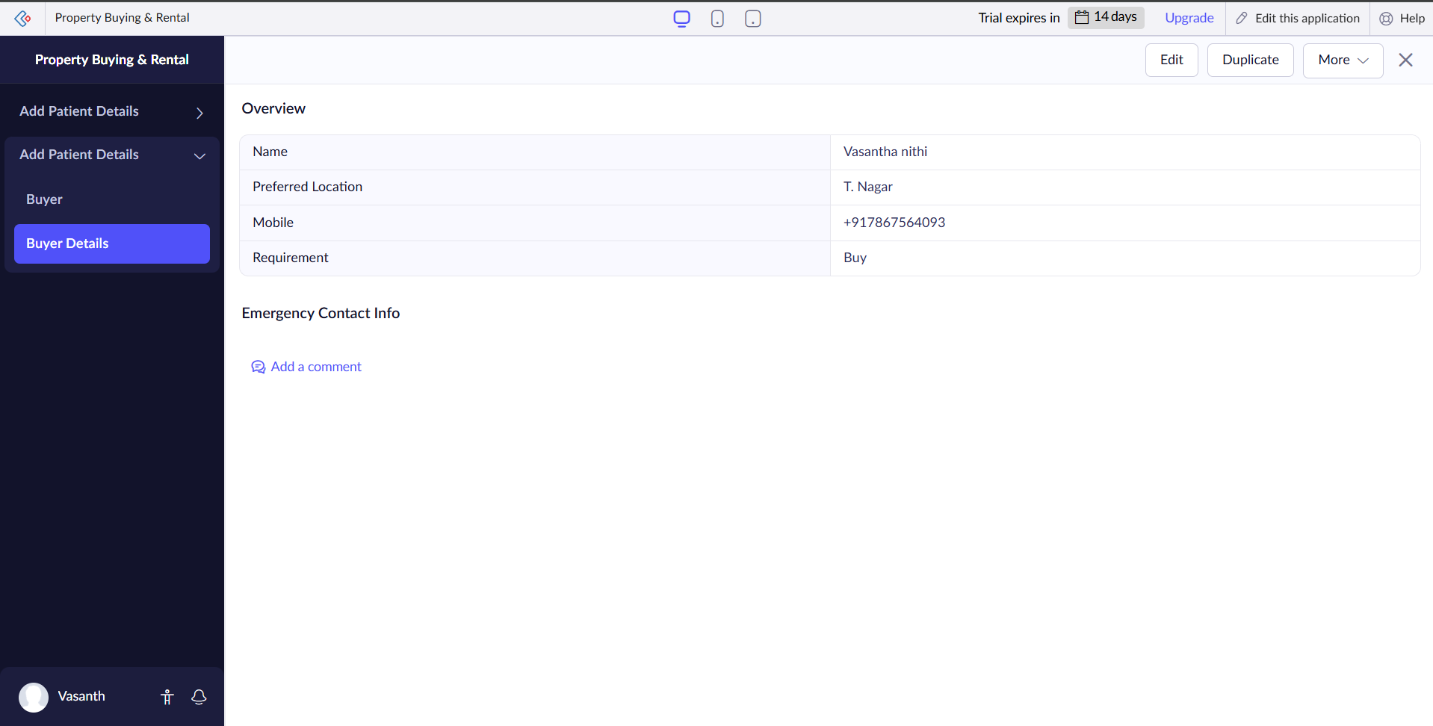

**Result:**

The **Property Buying & Rental Application** was successfully created in **Zoho Creator**.

* Buyers/Tenants can search and request properties.
* Owners can list properties.
* The application is accessible from anywhere, on any device, without installation, proving the **SaaS model**.